~Asia-China-Mirror-Shan-3

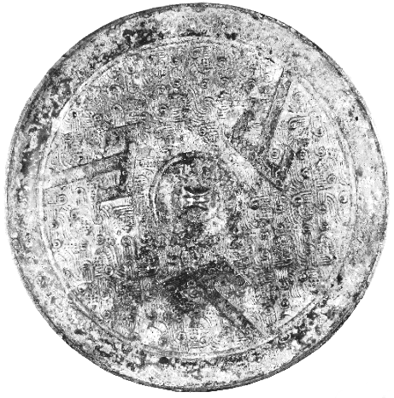

Rare bronze circular Three 'SHAN' mirror, Late Warring States Period, 4th-3rd c. BCE   
Thinly cast, the back with a ribbed central loop encircled by a concave band and crisply cast in the outer field with three large shan characters on a ground of hooked feather-like scrolls and granulation, with green patina. This style of mirror, with its use of the plain shan or T-shapes superimposed on a patterned ground, is typical of those from the Chu region of Hunan and Hubei provinces during the Warring States period. A similar mirror (20.cm.) in a Paris collection is illustrated in Zhongguo Qingtongqi Quanji - 16 - Bronze Mirrors, Beijing, 1998, p. 21, no. 21. Another similar mirror in the Museum of Far Eastern Antiquities is illustrated by B. Karlgren, "Early Chinese Bronze Mirrors: Classification Scheme Recapitulated," BMFEA, Stockholm, 1968, No. 40, pl. 22 (C 55), and again by D.M. O'Donoghue in "Reflection and Reception: The Origins of the Mirror in Bronze Age China," BMFEA, Stockholm, 1990, No. 62, p. 166, Fig. 64. See, also, the mirror of this type, with four shan characters alternating with four deer, illustrated in Ancient Bronze Mirrors from the Shanghai Museum, Shanghai, 2005, pp. 76-7, no. 3. Cf. example from Christie's sale 2658 / Lot 1406, $60K (http://m.christies.com/sale/lot/sale/23829/lot/5540015/p/1/from//enlarge/0?KSID=eab33dea69d0bcbde96ca7071108fa00).